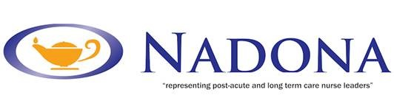
LPN Certification Prep Course
Must be completed in full and returned to receive Certificate of Completion

- ldentify at least one evidence based approach for caring for a client with a pressure ulcer.
A .
- Please describe how your knowledge increased in evidence based care for the dying.

2. Please describe how this course impacted your position or role at your facility or organization:

3. Did this course meet your expectations? Please explain.

4. Would you recommend this course to others?

5.Please rate your satisfaction with this course from 1 – 10 with 10 being the highest level of satisfaction.
1 ___ 2____ 3___ 4___ 5___ 6___ 7___ 8___ 9____ 10___

6. What would you suggest to make the content of this program better?

Thank you for completing the course. Your Certificate of Mastery will be sent after receipt of this evaluation and in the week designated.

