Minnesota Sample Antibiotic Stewardship Policy for Long-Term Care Facilities

Table of Contents:

Minnesota Sample Antibiotic Stewardship Policy for Long-Term Care Facilities
BACKGROUND 2
POLICY 2
PROCEDURE 3
- Leadership 3
- Accountability (Antibiotic Stewardship Team) 3
- Antibiotic Expertise 4
- Antibiotic Stewardship Actions 4
- Measuring Actions (Tracking) 6
- Reporting 7
- Education 7
REFERENCES 7
APPENDIX A. Loeb Criteria for Initiating Antibiotics 8
APPENDIX B. Standardized Form for Assessing and Communicating Suspected UTI 9
APPENDIX C. Standardized SBAR Form for Communication of Change in Condition 11
APPENDIX D. Criteria for Submission of Biologic Specimens for Laboratory Diagnostics 13
Part 1. Urine culture 13
Part 2. Algorithm to guide Clostridium difficile diagnostics 13
APPENDIX E. Measurement Protocols 14
Part 1. Antibiotic Use 14
Part 2. Stewardship Actions 14
Part 3. Outcomes 15

Infectious Disease Epidemiology, Prevention and Control Division Minnesota Department of Health
PO Box 64974
St. Paul, MN 55164-0975
651-201-5414 | 1-877-676-5414
www.health.state.mn.us

BACKGROUND:
Antibiotics are powerful tools for fighting and preventing infections. However, widespread use of antibiotics has resulted in an alarming increase in antibiotic-resistant infections and a subsequent need to rely on broad-spectrum antibiotics that might be more toxic and expensive. In addition to the development of antibiotic resistance, antibiotic use is associated with an increased risk of Clostridium difficile infection and adverse drug reactions. Since antibiotics are frequently over or inappropriately prescribed, a concerted effort to decrease or eliminate inappropriate use can make a big impact on resident safety and the reduction of adverse events. Antibiotic stewardship consists of coordinated interventions aimed at treating infections while promoting appropriate antibiotic use. The practice of antibiotic stewardship requires commitment, leadership, communication, and actions informed by best practice guidelines and defined protocols. In compliance with the current Centers for Medicare and Medicaid Services (CMS) Requirements of Participation for infection control in long-term care facilities, this Antibiotic Stewardship Policy outlines how [facility] will address this important health care issue.

POLICY:
It is the policy of [facility] to maintain an Antibiotic Stewardship Program (ASP) with the mission of promoting the appropriate use of antibiotics to treat infections and reduce possible adverse events associated with antibiotic use. Components of this policy were developed by using evidence-based practice guidelines and are aligned with the Core Elements of Antibiotic Stewardship for Nursing Homes, published by Centers for Disease Control and Prevention (CDC) (1), and the State Operations Manual (Appendix PP): Guidance to Surveyors of Long Term Care Facilities, published by CMS (2).
The [facility] ASP will incorporate all seven core elements outlined by CDC. Details of each element are described in the “Procedure” section of this policy document. This Policy, including the Procedure section, will be reviewed yearly to ensure that all objectives and conditions are being met, to streamline procedures and algorithms, and to identify opportunities for enhancement of the ASP.
The seven core elements of the [facility] ASP are:
- Leadership Commitment: We will dedicate time, financial, and technological ASP resources
- Accountability: We will have physician, nursing, and pharmacy leads responsible for promoting and overseeing antibiotic stewardship activities
- Drug Expertise: We will establish and maintain access to a consultant pharmacist(s) or other individual with antibiotic stewardship-specific drug expertise
- Action: We will implement policies and practices to improve antibiotic use
- Tracking: We will monitor antibiotic use and outcome(s) from antibiotic use
- Reporting: We will provide regular feedback on antibiotic use and resistance to prescribing clinicians, nursing staff, and other relevant staff
- Education: We will provide resources to clinicians, nursing staff, residents, and families about antibiotic resistance and appropriate antibiotic use
Key objectives for the ASP in 2017 will be to establish an ASP and a system for tracking antibiotic use to meet the requirements of participation set out by CMS. We will also implement a small number of additional antibiotic stewardship actions to improve communication about resident condition and antibiotic decision-making for potential urinary tract infections (UTI).

Anticipated objectives for ASP in 2018 will be to improve upon 2017 ASP activities, enhance antibiotic use tracking to measurement of days of therapy, implement communication and decision-making tools for potential infections outside of the urinary tract, and track multi-drug resistant infections.

PROCEDURE:
- Administrative Leadership
  - Identification of administrative leadership:
    - [leader name]
    - [leader name]
  - Administrative leadership will identify a physician, nursing, and pharmacy lead to be responsible for program oversight and promotion—the Antibiotic Stewardship Team (AST).
  - Administrative leadership and the AST will together develop an antibiotic stewardship mission statement.
  - A written leadership statement in support of antibiotic stewardship will be posted in the facility and made available to residents, families, and all staff.
  - Leadership will communicate annually with nursing staff and clinicians this commitment to antibiotic stewardship and the expectations of the nursing home regarding monitoring and enforcement of stewardship policies.

Accountability (Antibiotic Stewardship Team)
  - Team Role
    - Accountability for activities that support the antibiotic stewardship mission.
      - Define standards for antibiotic prescribing, communication, and other stewardship actions for staff and clinical providers credentialed to deliver care in the home
      - Communicate prescribing standards to staff and providers
    - Utilize antibiotic-use and other data to ensure that Antibiotic Stewardship Policy procedures and other best practices are followed and refined as needed.
      - Compile and share report of antibiotic use, process measures, and outcomes monthly
      - Identify any necessary procedure changes based on monthly reports
      - Work with laboratory annually to obtain local/regional antibiogram
    - Review the Antibiotic Stewardship Policy annually, as directed above.
  - Members
    - The AST will include, at minimum, the Medical Director, the Director of Nursing, Infection Prevention (IP) Coordinator, and a consultant pharmacist.
    - AST Lead: Title Responsibilities: _

    - AST Members:
      - Name Title Responsibilities:
      - Name Title Responsibilities:

      - Name Title Responsibilities:
      - Name Title Responsibilities:

Antibiotic Expertise
To reduce antibiotic use and guide development of ASP protocols, the AST Lead will collaborate as needed with:
  - Consultant pharmacist(s): [names]
  - Hospital ASP contacts in referral network: [names]
_
  - Infectious disease consultant(s): [names]
  - Other: [names]

Antibiotic Stewardship Actions
  - Background
Antibiotic stewardship actions are conducted to enable or to measure these key elements of care: knowing when to be concerned about an infection in a resident, what clinical and historical information to gather for the provider, when to submit diagnostic specimens to the laboratory, how to quantify and assess appropriateness of antibiotics prescribed, and how to identify adverse outcomes that might be associated with antibiotics.
Actions put into place by the AST will be monitored monthly (see Measuring Actions section on Page 5 of this document), discussed with leadership and appropriate consulting experts, and reviewed for necessary updates annually. Dates indicate when each action will be implemented as a mandatory part of this Antibiotic Stewardship Policy.
  - Actions
    - Prescription record keeping. Dose, duration, route, and indication of every antibiotic prescription MUST be documented in the medical record for every resident, regardless of prior prescriptions or documentation elsewhere (e.g., in medical record of a discharging facility). Notation of this information should be made on the day that an in- house prescription is written or on the day that a resident returns to the facility on an antibiotic prescribed elsewhere. Records will be reviewed monthly to assess compliance

with this requirement as well as prescription appropriateness for the individual resident, site, and type of infection.
Implementation date: November 1, 2017
    - Assessment of residents suspected of having an infection. Providers will utilize the Loeb Criteria when considering initiation of antibiotics (Appendix A) (4). Consistent with these criteria, the standardized Suspected UTI SBAR form should be used for all residents suspected of having a UTI (Appendix B). The completed form should be provided to, or information communicated with, the provider. It is encouraged that Loeb criteria be used for other suspected infections, including lower respiratory tract infection, skin and soft-tissue infection, and fever of unknown focus, when considering antibiotic prescription.
Implementation date: November 1, 2017
    - Provider communication. When UTI is suspected, the standardized Suspected UTI SBAR form (Appendix B) must be used to communicate with providers. It is encouraged that the standardized general SBAR form be used for all change in condition communication (Appendix C).
Implementation date: November 1, 2017
    - Antibiotic “time-out.” At 72 hours after antibiotic initiation or first dose in the facility, each resident will be reassessed for consideration of antibiotic need, duration, selection, and de-escalation potential. At this time, laboratory testing results, response to therapy, resident condition, and facility needs (e.g., outbreak situation) will be considered. Completion of an antibiotic time-out must be recorded in the resident record.
Implementation date: November 1, 2017
    - Microbiologic specimen submission guidelines. The following guidelines should be considered before submission of a clinical specimen for microbiologic testing:
      - Urinalysis: Loeb et al. algorithm (Appendix D) (4)
      - Urine culture: Loeb et al. algorithm (Appendix D) (4)
      - Stool testing for Clostridium difficile: Minnesota Dept. of Health algorithm (Appendix D) (5)
      - Wound culture
      - Respiratory diagnostics
      - Blood culture
Implementation dates: November 1, 2017 for a–c; November 1, 2018 for d–f
    - First-line treatment recommendations. There are no definitive practice guidelines that specifically address treatment of UTI in elderly patients in LTCF. Prescribers will base treatment recommendations on the following factors:
- Likely UTI site (i.e., cystitis or pyelonephritis)
- Facility-specific culture and antibiotic sensitivity data
- Patient-specific factors including age, sex, prior antibiotic use, allergy history, concomitant drug therapy, renal function, and presence of urinary catheter

Although fluoroquinolone antibiotics have historically been extensively used to treat UTI, recent concerns include contributions to the emergence of bacterial resistance, the

increasing prevalence of C. difficile infection, and potential toxicity, have led to recommendations to curb fluoroquinolone use.
Implementation date: November 1, 2017
    - Multi-drug resistant infections. The AST will design and utilize systems to 1) identify residents with multidrug-resistant organisms (MDROs) by review of microbiology culture results, 2) alert staff and providers, and 3) document in cases of inter-facility transfer.
Implementation date: November 1, 2018
    - Interventions for syndrome-specific antibiotic use and antibiotic prophylaxis. The AST will identify actions to directly impact inappropriate antibiotic use for specific syndromes and for prophylactic indications.
Implementation date: November 1, 2018

Measuring Actions (Tracking)
  - Measurement/tracking objective
We will monitor antibiotic use, stewardship actions, and outcomes related to antibiotic use (excluding topical and ophthalmic antibiotics) in order to guide practice change and track ASP impact.
  - What will be measured/tracked
    - Measurements to be initiated on November 1, 2017:
Antibiotic use: Antibiotic starts
Stewardship actions: Record-keeping protocol compliance, use of antibiotic time-outs
Outcomes: Clostridium difficile detection
    - Measurements to be initiated on November 1, 2018:
Antibiotic use: Days of therapy (DOT)
Stewardship actions: Record-keeping protocol compliance, use of antibiotic time-outs, compliance with urine culture specimen submission guidelines
Outcomes: Clostridium difficile infections, urinary tract infections, antibiotic costs
  - Measurement process

Antibiotic use
      - [responsible person (e.g., IP Coordinator)] will develop a protocol for tracking antibiotic use. The protocol will be included in Appendix E and will include tracking of specific key aspects of antibiotic use data for each resident.
      - Antibiotic use data will be compiled monthly and reviewed by the consulting pharmacist. Consulting pharmacist and [responsible person] will interpret the monthly data, define any necessary action steps, and compile information for the Monthly ASP Tracking Report.

Stewardship actions
      - [responsible person] will develop a system for measuring stewardship action. The measurement protocol will be included in Appendix E.

      - Data will be compiled monthly by [responsible person] , who will interpret monthly data, define any necessary action steps, and compile information for the Monthly ASP Tracking Report.

Outcomes
      - [responsible person] will develop a system for tracking outcomes. The outcomes tracking protocol will be included in Appendix E.
      - Outcomes data will be compiled monthly by [responsible person] , who will interpret monthly data, define any necessary action steps, and compile information for the Monthly ASP Tracking Report.

Reporting
A Monthly ASP Tracking Report will be compiled and will include summaries of collected data; interpretation of data by consulting pharmacist, IP Coordinator, and other relevant individuals; and identified next action steps. The Monthly ASP Tracking Report will be discussed at a full AST meeting, or Quality Assurance Performance Improvement meeting, and disseminated to administrative leadership identified in Procedure Section 1 of this document.
An Annual ASP Tracking Report will be developed and will include the components of data summary, interpretation, and next steps, as well as identification of ASP measurement targets identified for the following year.

Education
[facility] will provide antibiotic stewardship education to staff, prescribing providers, residents, and families. The education plans are defined below.
Staff: Upon hire: [description of AS education] Annually: Prescribing providers: Residents: Families:

REFERENCES:
- CDC. The Core Elements of Antibiotic Stewardship for Nursing Homes. Atlanta, GA: US Department of Health and Human Services, CDC; 2015. Available at: http://www.cdc.gov/longtermcare/index.html
- CMS. Pub. 100–07 State Operations Manual, Appendix PP, Guidance to Surveyors of Long Term Care Facilities. Washington D.C.: US Department of Health and Human Services, CMS; 2017. Available at: https://www.cms.gov/Medicare/Provider-Enrollment-and- Certification/GuidanceforLawsAndRegulations/Downloads/Advance-Appendix-PP-Including-Phase-2-.pdf
- Loeb et al. Development of Minimum Criteria for the Initiation of Antibiotics in Residents of Long-Term–Care Facilities: Results of a Consensus Conference. Infection Control & Hospital Epidemiology 2001;22(2):120-4.
- Loeb et al. Effect of a multifaceted intervention on number of antimicrobial prescriptions for suspected urinary tract infections in residents of nursing homes: cluster randomised controlled trial. British Medical Journal 2005. doi:10.1136/bmj.38602.586343.55.
- Minnesota Antimicrobial Stewardship Program Toolkit for Long-term Care Facilities. Appendix M: Prevention and Management of Clostridium difficile Infections in Long-term Care. http://www.health.state.mn.us/divs/idepc/dtopics/antibioticresistance/asp/ltc/index.html

APPENDIX A. Loeb Criteria for Initiating Antibiotics
From: Loeb et al. Development of Minimum Criteria for the Initiation of Antibiotics in Residents of Long-Term–Care Facilities: Results of a Consensus Conference. Infection Control & Hospital Epidemiology 2001;22(2):120-4. http://www.health.state.mn.us/divs/idepc/dtopics/antibioticresistance/ltcabxcard.html
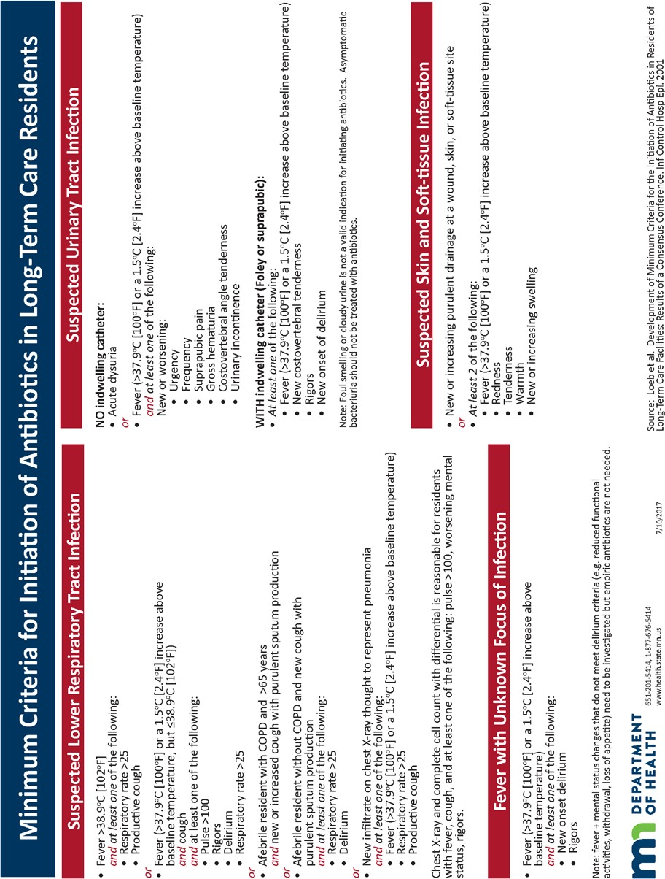

APPENDIX B. Standardized Form for Assessing and Communicating Suspected UTI
From: Agency for Healthcare Research and Quality. Nursing Home ASP Guide. 2014;Pub. No. 14-0010-2-EF.
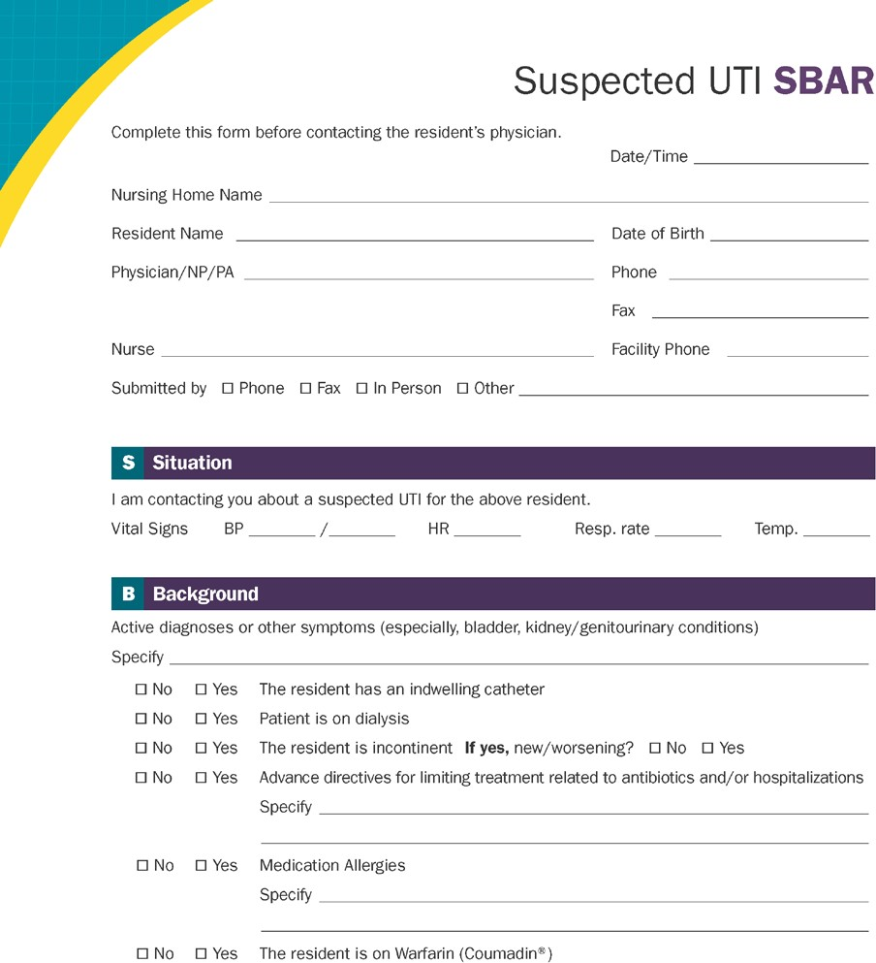
https://www.ahrq.gov/sites/default/files/wysiwyg/nhguide/4_TK1_T1-SBAR_UTI_Final.pdf

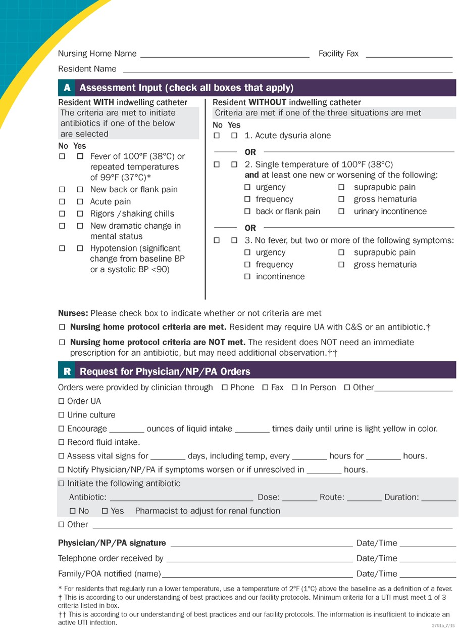

APPENDIX C. Standardized SBAR Form for Communication of Change in Condition
From: Minnesota Antimicrobial Stewardship Program Toolkit for Long-term Care Facilities. Appendix G: SBAR: Situation, Background, Assessment, Request http://www.health.state.mn.us/divs/idepc/dtopics/antibioticresistance/asp/ltc/apxg.pdf

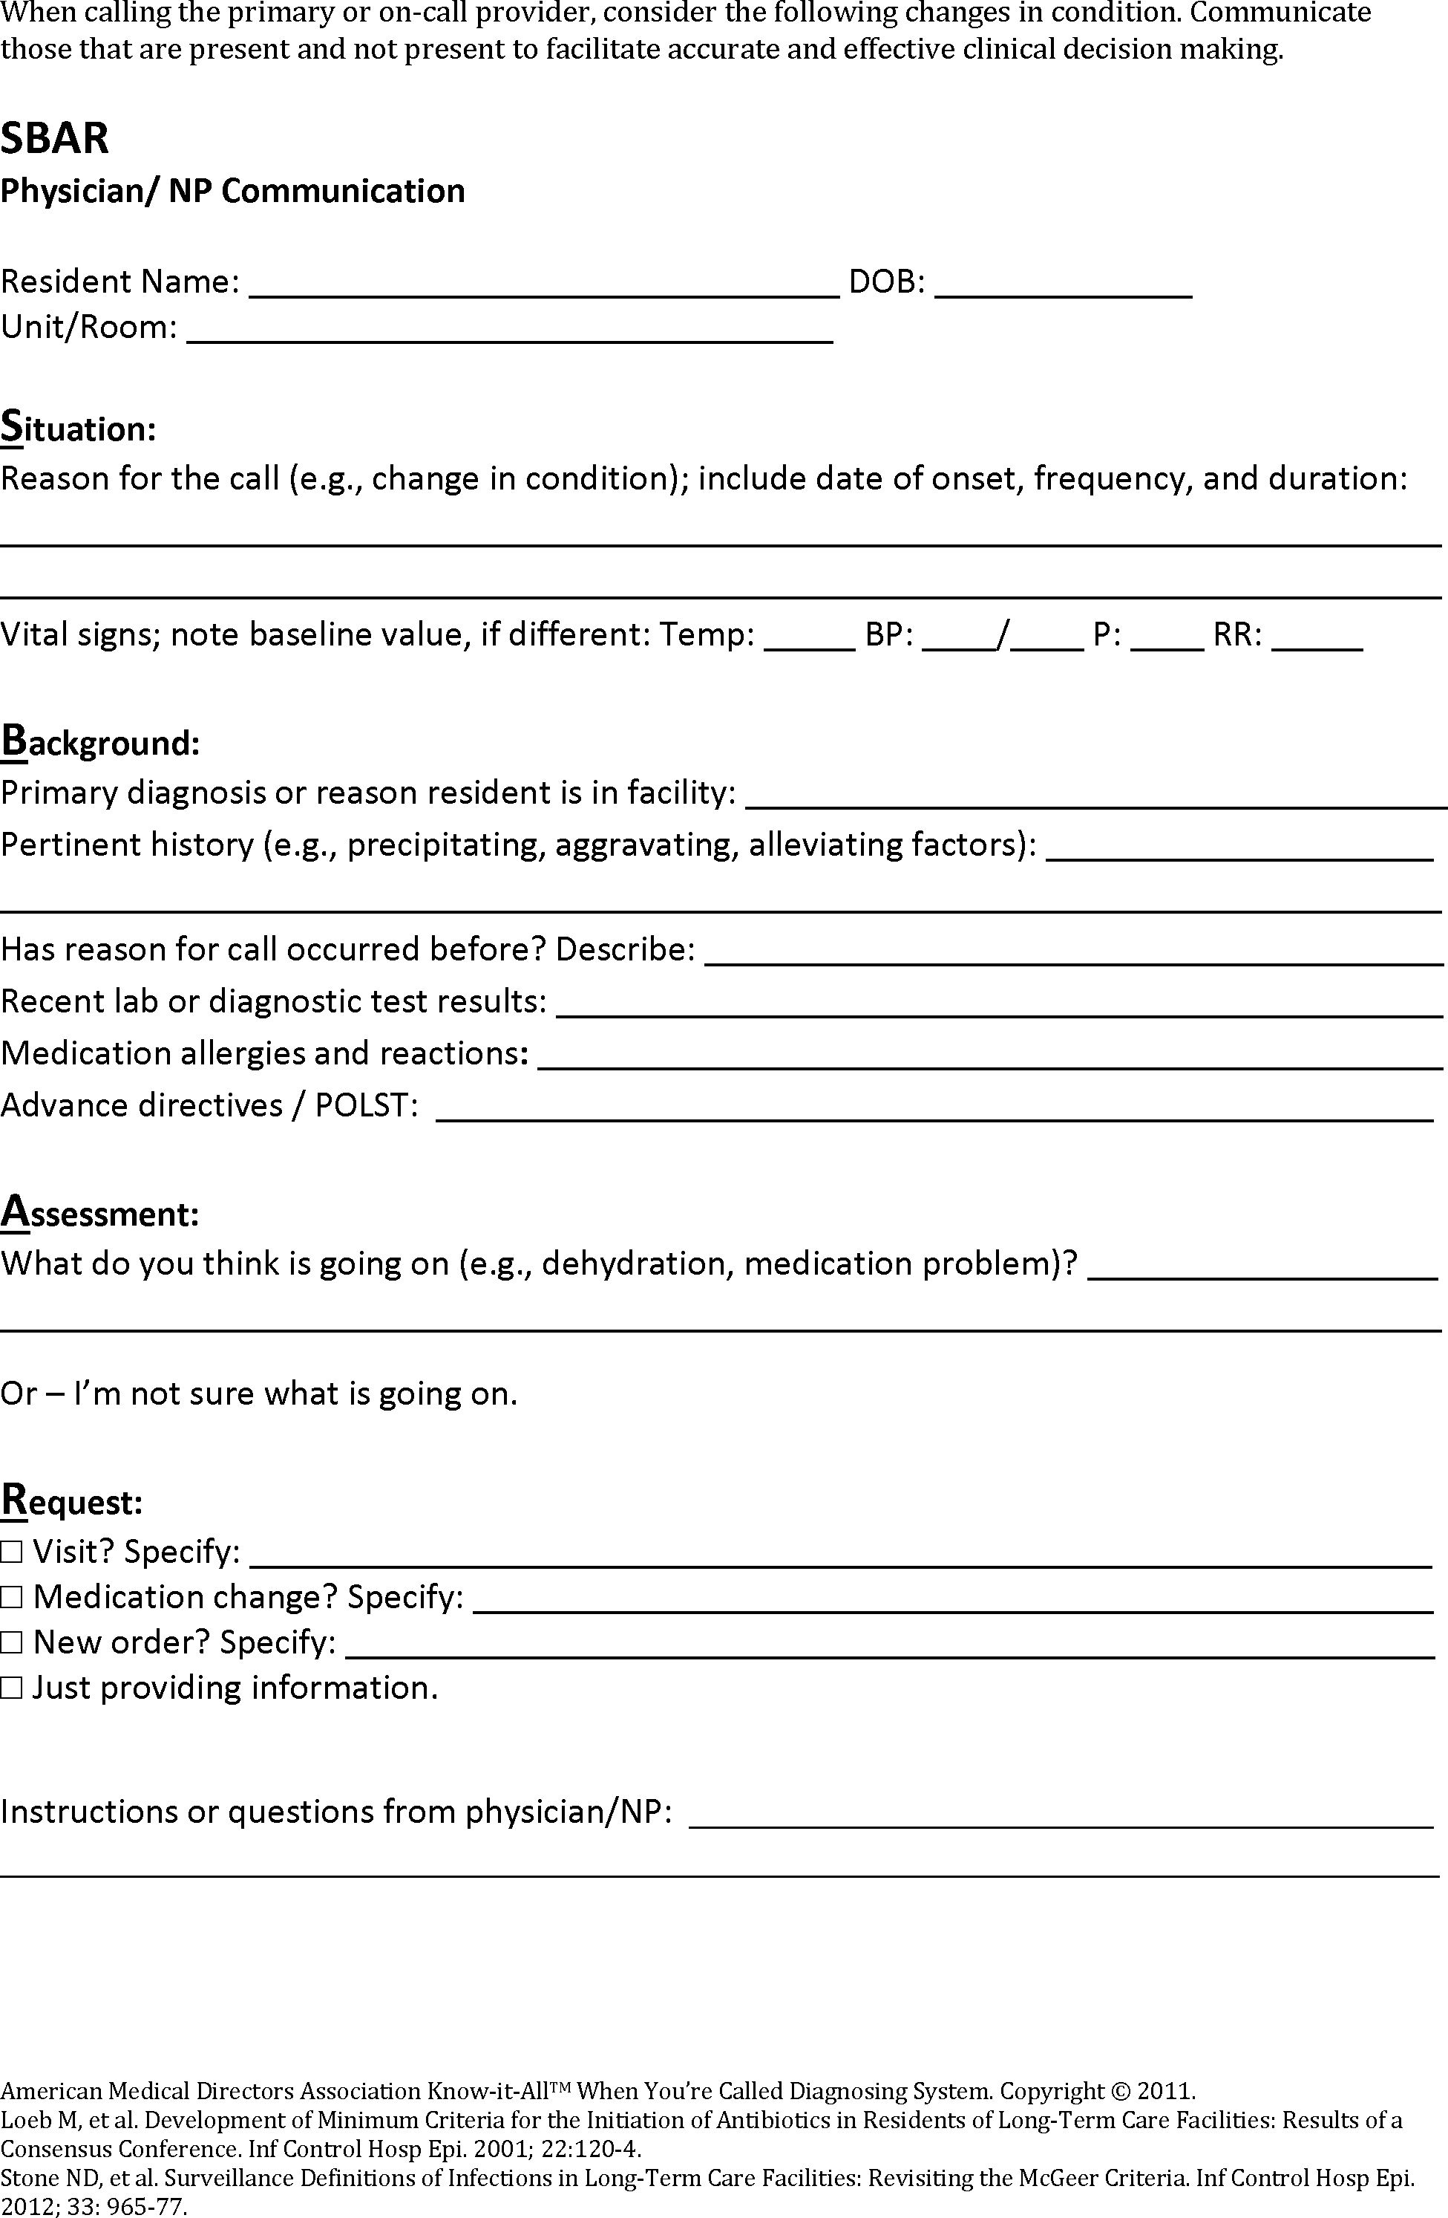

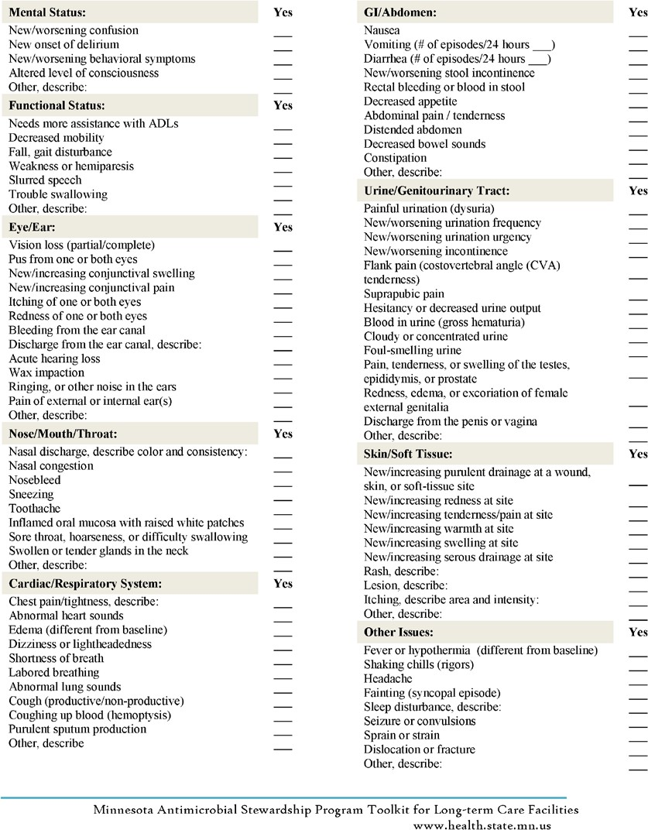

APPENDIX D. Criteria for Submission of Biologic Specimens for Laboratory Diagnostics

Part 1. Urine culture
From: Loeb et al. Effect of a multifaceted intervention on number of antimicrobial prescriptions for suspected urinary tract infections in residents of nursing homes: cluster randomised controlled trial. British Medical Journal 2005. doi:10.1136/bmj.38602.586343.55
This algorithm will be used to guide decisions about when to order a urine culture. It should be considered by providers in concert with information reported on the Suspected UTI SBAR form.
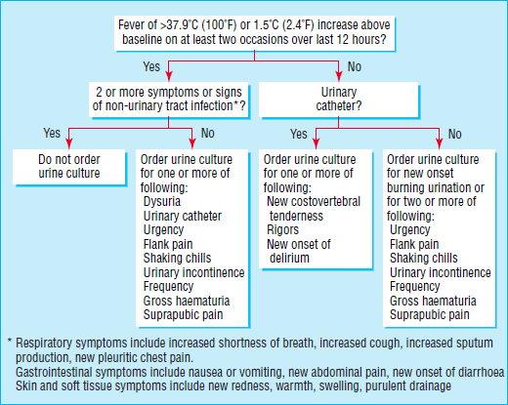
Part 2. Algorithm to guide Clostridium difficile diagnostics
From: Minnesota Antimicrobial Stewardship Program Toolkit for Long-term Care Facilities. Appendix M: Prevention and Management of Clostridium difficile Infections in Long-term Care. http://www.health.state.mn.us/divs/idepc/dtopics/antibioticresistance/asp/ltc/apxm.pdf
This algorithm will be used to guide decisions about when to collect a stool sample. It should be considered by providers in concert with information reported on the SBAR form.
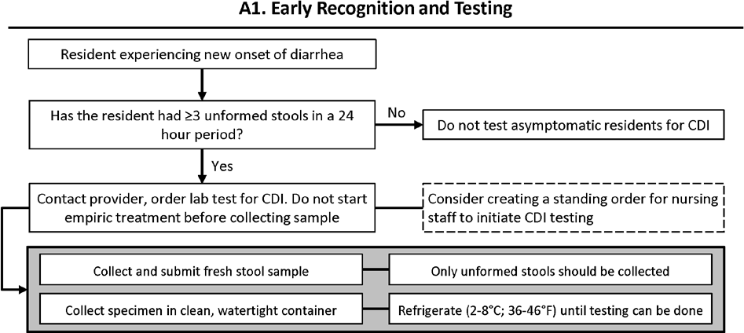

APPENDIX E. Measurement Protocols

Part 1. Antibiotic Use
Antibiotic Starts
- Measurement
  - The electronic health record system will be used to generate a list of all residents given an antibiotic prescription (“antibiotic start”) by a provider located in or outside of the facility.
  - A Microsoft Excel Antibiotic Use Database will be developed for antibiotic use tracking.
    - Each antibiotic start for a resident will be listed in a separate row. Some residents might be listed in more than one row, if they have had more than one course of antibiotics during the month.
    - Columns to be included in the database are:
      - Resident name
      - Antibiotic name
      - Indication for antibiotic
      - Route of administration
      - Dose of antibiotic
      - Prescribed length of antibiotic course (days)
      - Prescriber and prescribing facility
      - Antibiotic time-out occurred? (yes/no)
  - The medical record of each resident receiving an antibiotic that month will be reviewed and the appropriate information filled into the Excel database.
- Review and Reporting
  - The database will be reviewed by the consulting pharmacist once monthly to assess appropriateness of prescribing.
  - For the Monthly ASP Tracking Report, the following calculations will be completed and reported:
    - Total number of antibiotic starts
    - Number and percent of antibiotic starts by antibiotic name and class
    - Number and percent of antibiotic starts originating from facility providers and outside providers

Part 2. Stewardship Actions
Prescription Record-Keeping Compliance
- Measurement
  - The [facility] Antibiotic Stewardship Policy requires that the dose, duration, and indication of every antibiotic prescription must be documented in the medical record for every resident, regardless of prior prescriptions or documentation elsewhere (e.g., in medical record of a discharging facility).
  - Each month, the Antibiotic Use Database will be reviewed to look for completeness of these data.
    - A new column will be added to the Microsoft Excel Antibiotic Use Database, titled, “Record Complete”
    - Each line of the database will be assessed to determine whether dose, duration, and indication were recorded. If none of these data are missing, the “Record Complete” cell is marked as “yes”
- Reporting
  - For the Monthly ASP Tracking Report, the following calculations will be completed and reported.

    - Number and percent of resident antibiotic starts with all of dose, duration, and indication recorded
    - Number and percent of antibiotic starts with dose recorded
    - Number and percent of antibiotic starts with duration recorded
    - Number and percent of antibiotic starts with indication recorded
    - Number and percent of resident records with complete dose, duration, indication information, by location of prescription (i.e., inside or outside of the facility)

Use of Antibiotic Time-Outs
- Measurement
  - Data about the occurrence of antibiotic time-outs will be collected during compilation of the monthly Microsoft Excel Antibiotic Use Database.
- Reporting
  - For the Monthly ASP Tracking Report, the following calculations will be completed and reported.
    - Number and percent of antibiotic starts that were followed up by an antibiotic time-out
    - Number and percent of antibiotic starts that were followed up by an antibiotic time-out, by location of prescription (i.e., inside or outside of the facility)

Part 3. Outcomes
Clostridium difficile Detection
- Measurement
  - The electronic health record system will be used to generate a list of all residents with a positive
C. difficile diagnostic test submitted by a provider located in or outside of the facility.
  - A Microsoft Excel C. difficile Database will be developed for tracking.
    - Each resident diagnosed with C. difficile will be listed in a separate row.
    - Columns to be included in the database are:
      - Resident name
      - Date of specimen collection for positive C. difficile test
      - Room number when test positive
      - Presence of ≥3 loose stools within 24 hour period before test? (yes/no)
      - Received antibiotics within 30 days prior to positive test? (yes/no)
  - The medical record of each resident with a positive C. difficile test that month will be reviewed and the appropriate information filled into the Excel database.
- Reporting
  - For the Monthly ASP Tracking Report, the following calculations will be completed and reported.
    - Number of residents with a positive C. difficile diagnostic test
    - Number and percent of residents positive for C. difficile that had ≥3 loose stools within 24 hours prior to diagnostic test
    - Number and percent of residents positive for C. difficile that received antibiotics in 30 days before testing

